Template

for Unit Test Documentation

This Appendix describes the template for the Unit Test Documentation, which is positioned in the workflow diagram as follows.

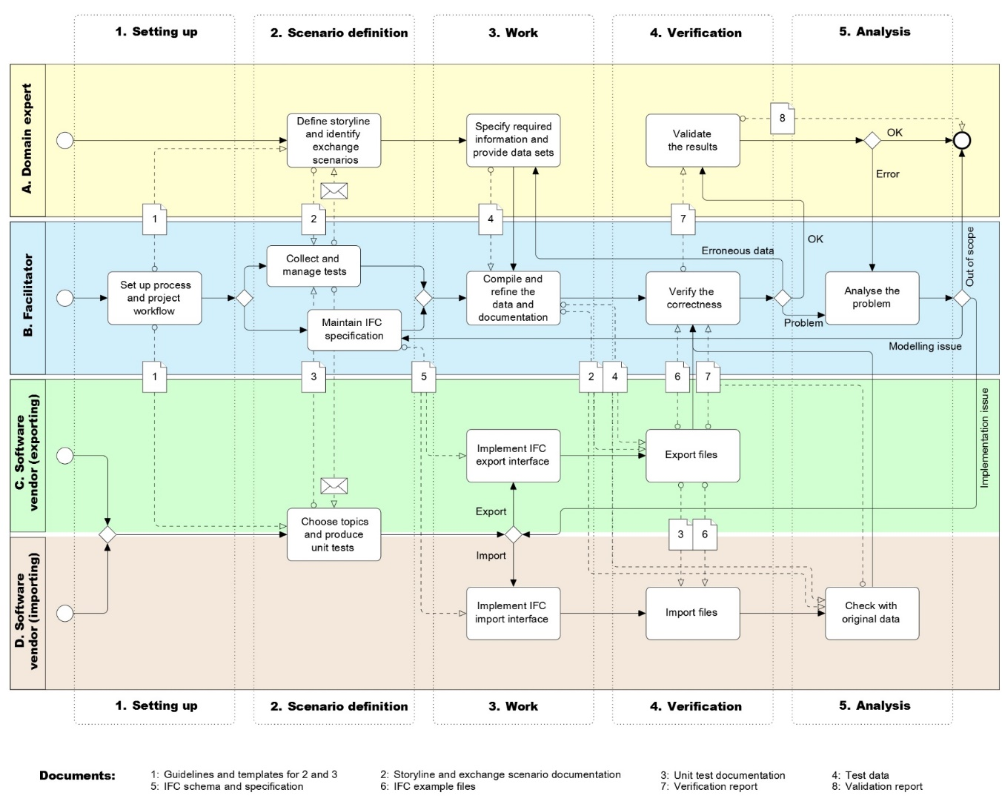

|  |  |  |  |  |
| --- | --- | --- | --- | --- |
|  |  |  |  |  |
| Room: | Infrastructure Room |  | **Date:** | 2019.06.12 |
| **Project/Activity:** | IFC Road |  | **Author:** | Štefan Jaud |
| **Document Title:** | WP5: Implementation Scenario GeoRef_1 |  | **Company:** | ProVI GmbH |
| **Version:** | 1.0 |  |  |  |

Unit Test GeoRef_1 : Georeferencing 1

|  |
| --- |
| Intent This Unit Test encapsulates the model set up with correct units and georeferencing.  The scenario in this Unit Test puts the project’s base point at the entrance to the Technical University of Munich, aligns the coordinate axes with East and North, and sets the units of the project to SI units. |
| Prerequisites This scenario builds upon following scenarios:   * None |
| Content The scenario covers the following additional concepts and/or entities:   * Project structure * Default units assignment * Georeferencing meta-data of the project’s coordinate system |
| Supporting files Following files correspond to this scenario:   * IR-Road-WP5_Scenario_GeoRef_1.docx : this document * IR-Road-WP5_Scenario_GeoRef_1.ifc : the exported content as IFC * IR-Road-WP5_Scenario_GeoRef_1_1.png : screen shot of the spot on BayernAtlas * IR-Road-WP5_Scenario_GeoRef_1_2.jpg : schematic representation of georeferencing entities |
| Version 1.0: Initial version (2019.06.12.) |